* + 1. **JAVA PROGRAMS**

**1.WRITE A JAVA PROGRAM TO CREATE A BASE CLASS VEHICLE WITH METHODS START ENGINE AND STOP ENGINE CREATE TWO SUBCLASSES CAR AND MOTOR CYCLE OVERIDE THE START ENGINE AND STOP ENGINE METHODS IN EACH SUB CLASSES TO START AND STOP THE ENGINE DIFFERENTLY.**

class Vehicle {

void startEngine() {

System.out.println("Starting the engine...");

}

void stopEngine() {

System.out.println("Stopping the engine...");

}

}

class Car extends Vehicle {

@Override

void startEngine() {

System.out.println("Car engine is starting with a roar!");

}

@Override

void stopEngine() {

System.out.println("Car engine is stopping with a smooth hum.");

}

}

class Motorcycle extends Vehicle {

@Override

void startEngine() {

System.out.println("Motorcycle engine is revving up!");

}

@Override

void stopEngine() {

System.out.println("Motorcycle engine is shutting down with a purr.");

}

}

public class Main {

public static void main(String[] args) {

Vehicle myCar = new Car();

Vehicle myMotorcycle = new Motorcycle();

System.out.println("Testing Car:");

myCar.startEngine();

myCar.stopEngine();

System.out.println();

System.out.println("Testing Motorcycle:");

myMotorcycle.startEngine();

myMotorcycle.stopEngine();

}

}

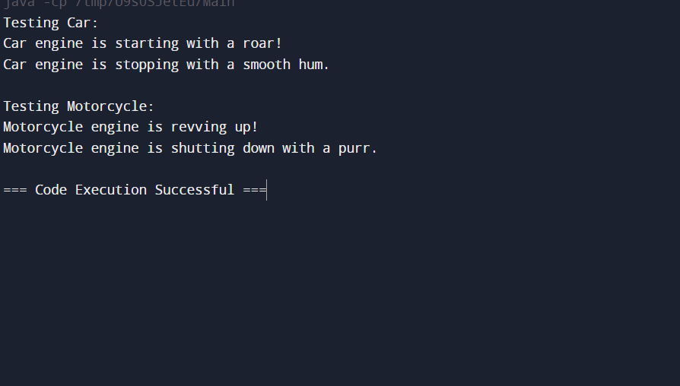

**2. WRITE A JAVA PROGRAM IF NUMBER IS LESS THAN 10 AND GREATER THAN 50 IT GENERATES EXCEPTION OUT OF RANGE HENCE DISPLAY THE SQUARE OF NUMBERS.**

class OutOfRangeException extends Exception {

public OutOfRangeException(String message) {

super(message);

}

}

public class NumberSquareCalculator {

public static void displaySquare(int number) throws OutOfRangeException {

if (number < 10 || number > 50) {

throw new OutOfRangeException("Number " + number + " is out of range. It should be between 10 and 50.");

} else {

int square = number * number;

System.out.println("The square of " + number + " is " + square);

}

}

public static void main(String[] args) {

int[] numbers = {5, 15, 55, 25};

for (int number : numbers) {

try {

displaySquare(number);

} catch (OutOfRangeException e) {

System.out.println(e.getMessage());

}

}

}

}

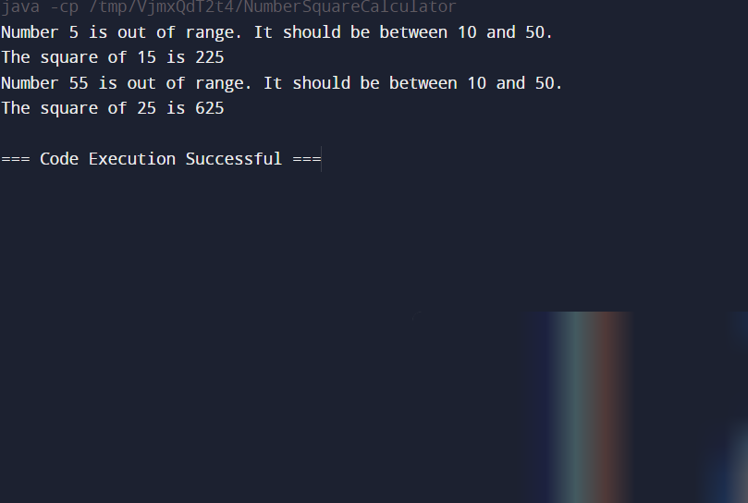

**3.CREATE PROGRAM IN JAVA TO CREATE ABSTRACT CLASS A ALSO CLASS B INHERITS CLASSA GENERATE OBJECT FOR CLASS B AND DISPLAY THE TEXT"CALL ME FROM B"**

abstract class A {

abstract void display();

void printMessage() {

System.out.println("Message from class A");

}

}

class B extends A {

@Override

void display() {

System.out.println("Call me from B");

}

}

public class Main {

public static void main(String[] args) {

B objB = new B();

objB.display();

objB.printMessage();

}

}

